**OPTIMIZING USER, GROUP,AND ROLE MANAGEMENT WITH ACCESS CONTROL AND WORKFLOWS**

**Team ID:NM2025TMID13817**

**Team Size :4**

**Team Leader : POONGOTHAI M**

**Team Member: SAJITH V**

**Team Member: MOHAMMED TAYABUDEEN R**

**Team Member: AYYANAR A**

**Problem Statement:**

**Organizations often face inefficiencies in managing user access, roles, and permissions, especially when scaling. Without a centralized and dynamic system, there's a high risk of unauthorized access, manual errors, and compliance issues. Our project aims to address these challenges by designing a system That streamlines user,group,and role management with integrated access control and approval workflows.**

**Objective:**

**To develop a secure, scalable, and automated system that allows administratorstoefficientlymanageusers,roles,andpermissions,along**

**withworkflowsthatenforceaccesscontrolpoliciesacrosstheorganization.**

# Skills:

* **Role-Based Access Control(RBAC)**
* **User &Group Management Systems**
* **Backend Development (e.g., Node.js, Django, or Spring Boot)**
* **FrontendUI (e.g.,React,Angular)**
* **Workflow AutomationTools**
* **Database Design(SQL/NoSQL)**
* **Authentication& Authorization(OAuth2,JWT)**
* **CloudPlatforms(e.g.,AWS,Azure,GCP)**

# TASKINITIATION:

**Startwithresearchandrequirementgathering.Definekey components like:**

* **Userregistration/authenticationmodule**
* **Role&permissionmatrix**
* **Accesscontrolrulesengine**
* **Approvalworkflowmodule**
* **Admindashboard**

## CreateUsers

* 1. Openservice now
  2. ClickonAll>>searchfor users
  3. SelectUsersundersystemsecurity
  4. Clickonnew
  5. Fill the followingdetailstocreatea newuser
  6. Clickonsubmit

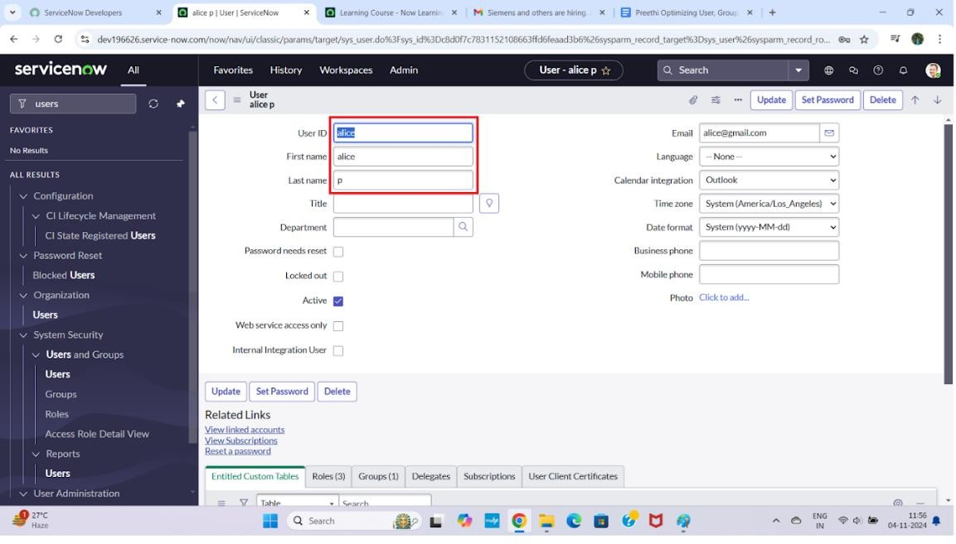

**Createonemoreuser:**

* 1. Create another user with the following details
  2. Click on submit

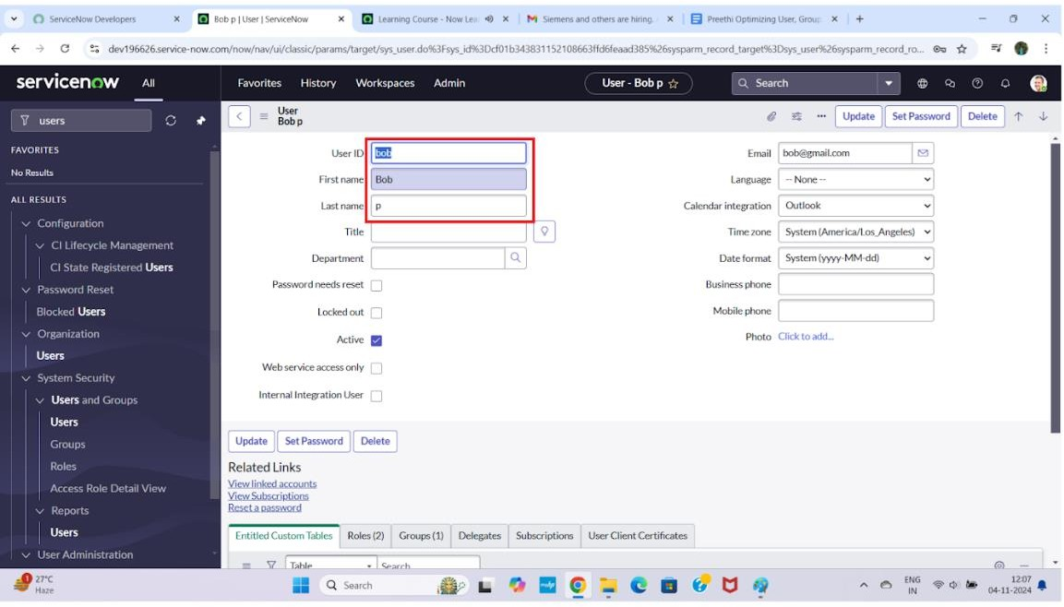

1.

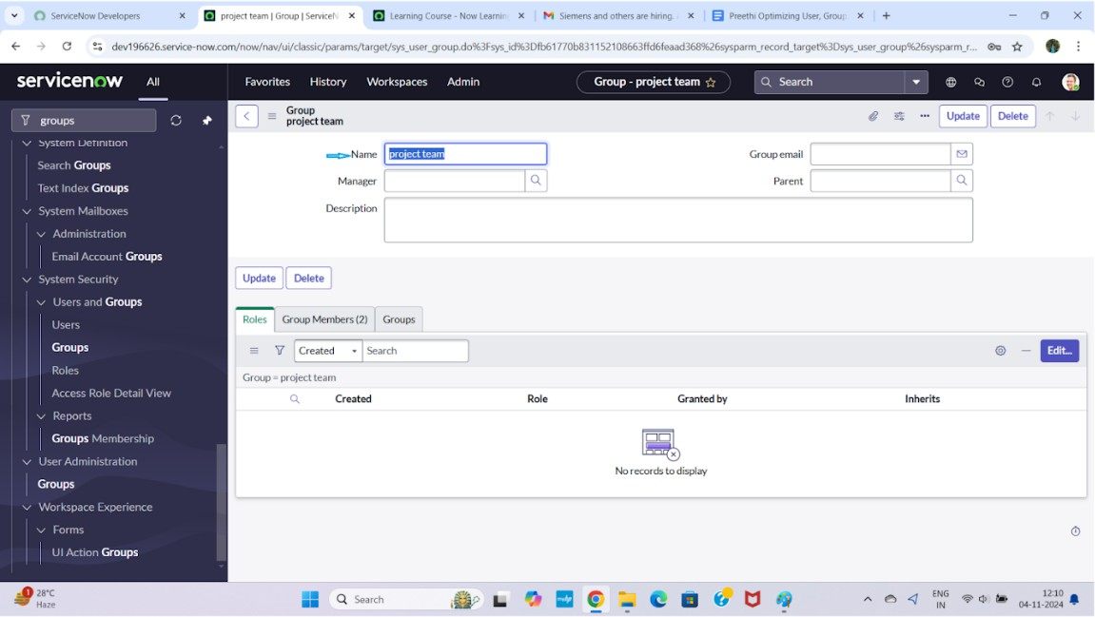

## CreateRoles

1. Open servicenow.
2. Click on All>>search for roles
3. Select roles under system security
4. Click on new
5. Fill the following details to create a newrole
6. Click on submit

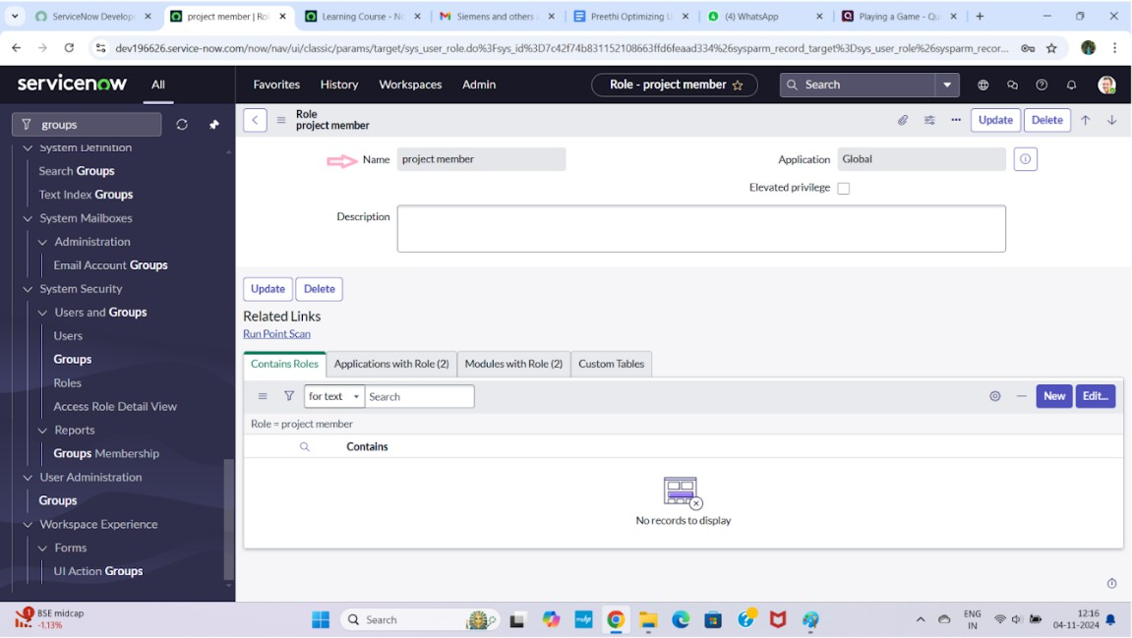

## Create one morerole:

1. Create another role with the following details :Team member
2. Click on submit

## CreateTable

* 1. Open servicenow.
  2. Click on All>>search for tables
  3. Select tables under system definition
  4. Click on new
  5. Fill the following details to create a new table Label : project table

Check the boxes Create module&Create mobile module

* 1. Under new menu name: projecttable
  2. Under table columns give the columns

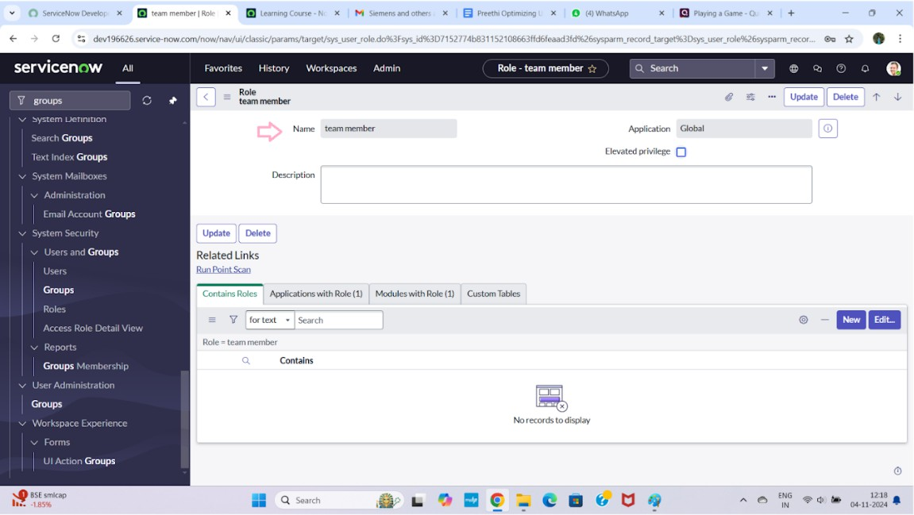

* 1. Click on submit

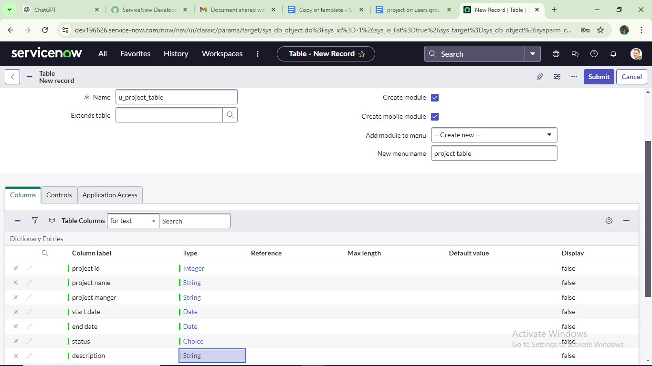

## Create one more table:

* 1. Create another table as:tasktable2 and fill with following details.
  2. Click onsubmit.

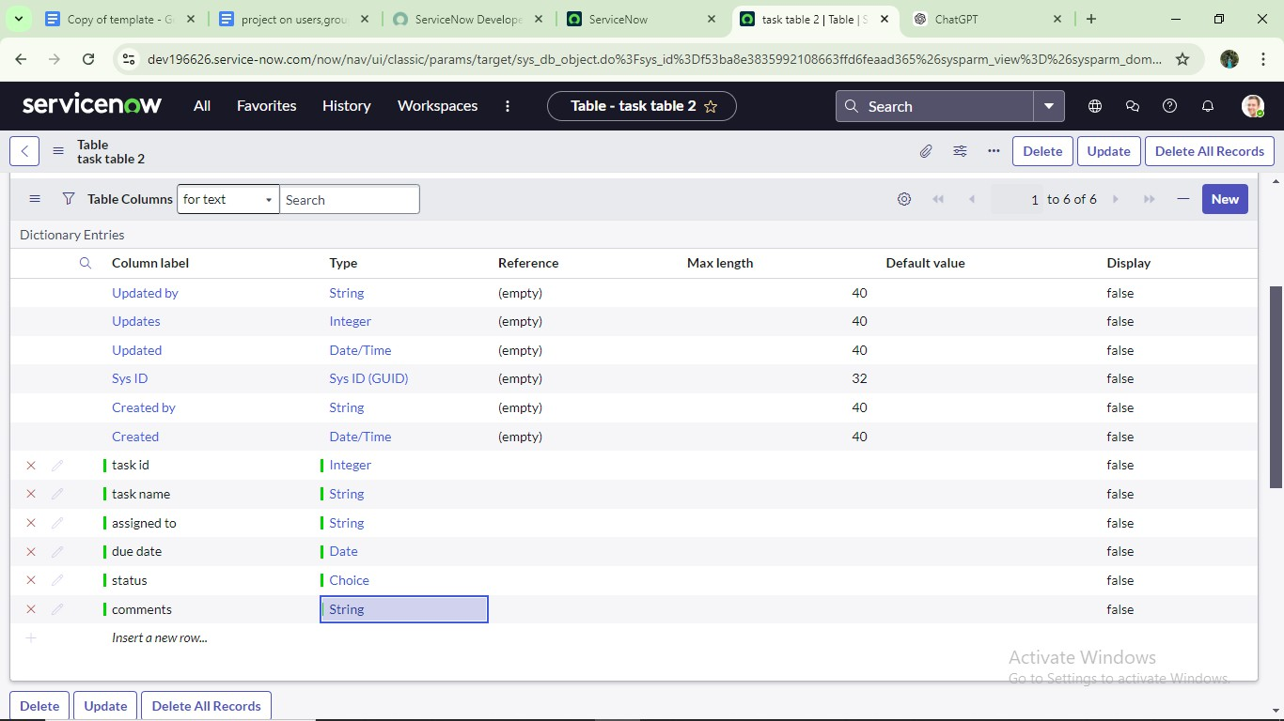

## Assign users toproject teamgroup

1. Open servicenow.
2. Click on All>>searchforgroups
3. Select tables under system definition
4. Select the project team group
5. Under group members
6. Click on edit
7. Select alice pandbob pandsave

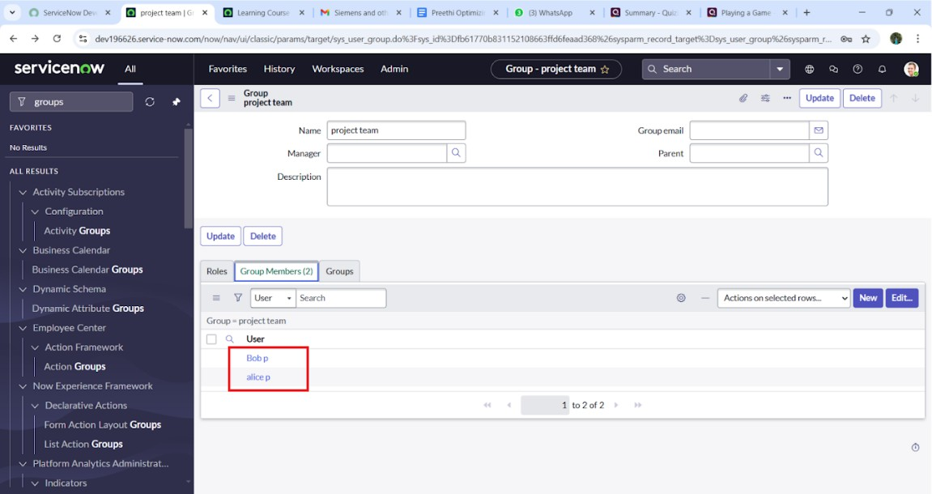

## Assignrolestoaliceuse

* 1. Openservicenow.ClickonAll>>searchforuser
  2. Selecttablesundersystemdefinition
  3. Selecttheprojectmanageruser
  4. Underprojectmanager
  5. Clickon edit
  6. Selectprojectmemberandsave
  7. clickoneditaddu_project_tableroleandu_task_tablerole
  8. clickonsaveandupdatetheform.

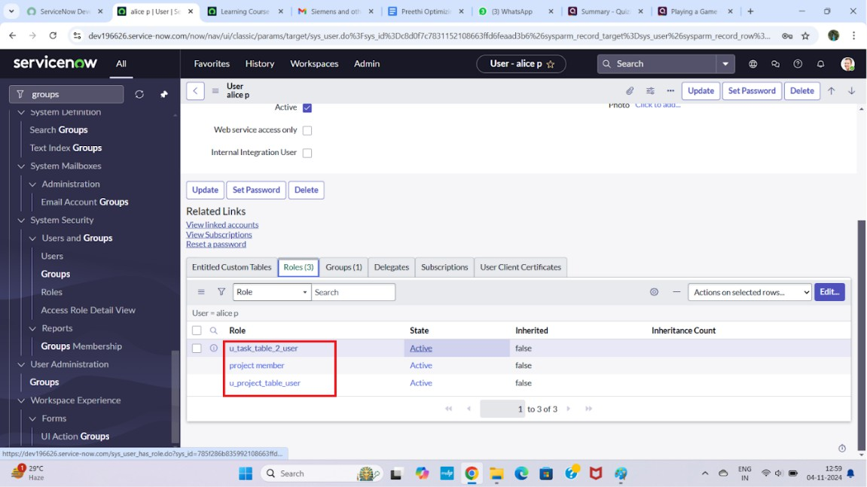

## Assignrolestobobuser

1. OpenServiceNow.ClickonAll>>searchforuser
2. Selecttablesundersystemdefinition
3. Selectthebobpuser
4. Underteammember
5. Clickon edit
6. Selectteammemberandgivetableroleandsave
7. ClickonprofileiconImpersonateusertobob
8. Wecanseethetasktable2.

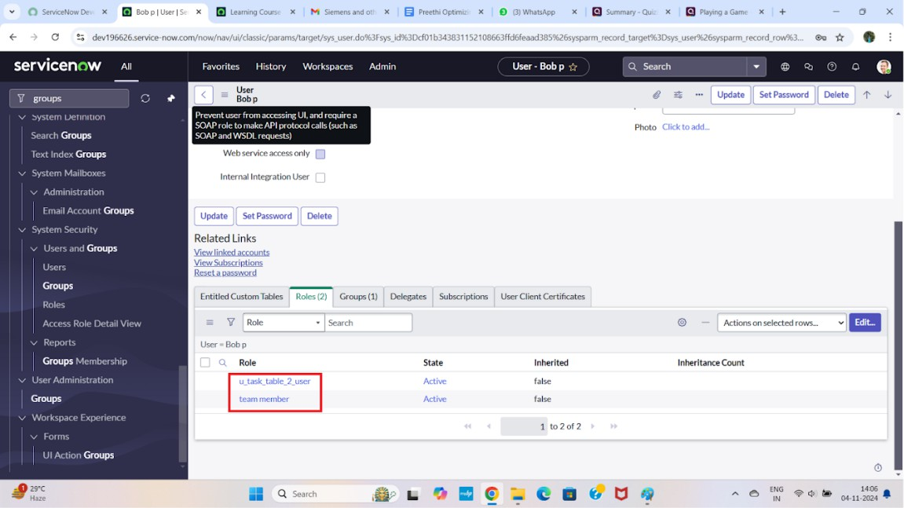

## Assigntableaccesstoapplication

* 1. whilecreatingatableitautomaticallycreateaapplicationandmoduleforthattable
  2. Gotoapplicationnavigatorsearchforsearchprojecttableapplication
  3. Clickoneditmodule
  4. Giveprojectmemberrolestothatapplication
  5. Searchfortasktable2andclickoneditapplication.
  6. Givetheprojectmemberandteammemberrolefortasktable2application

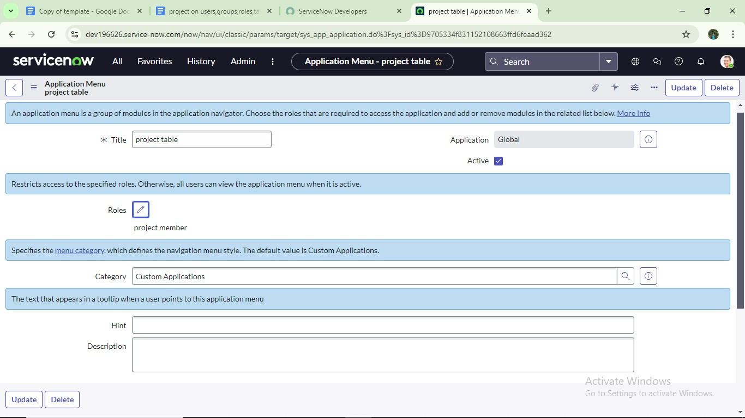

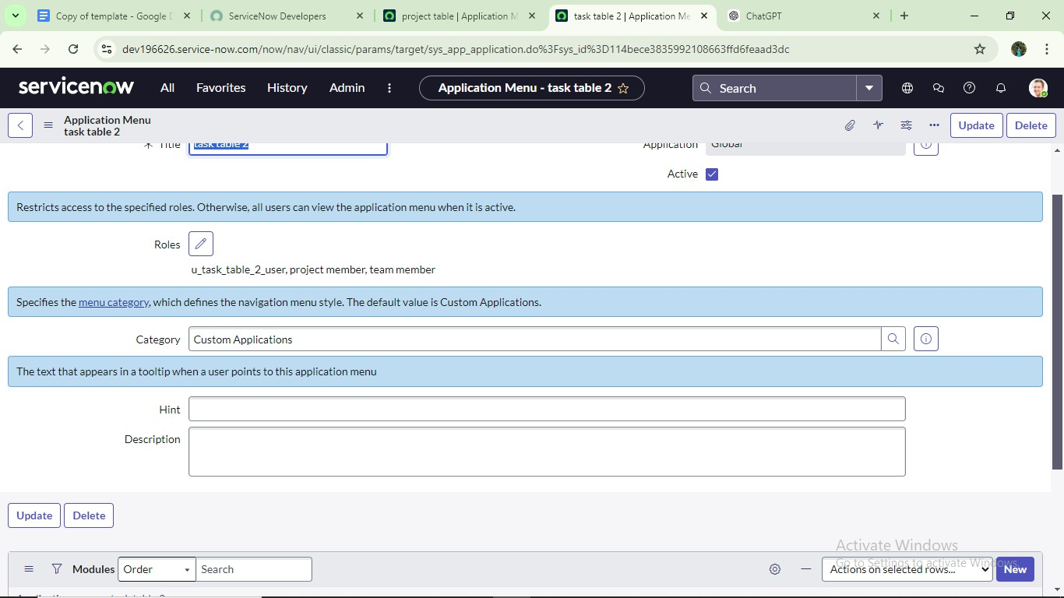

**Conclusion:**

This scenario highlights a structured approach to project management,

showcasingtherolesofAliceandBobwithinadefinedworkflow.WithAlice's oversight and Bob's execution, the team effectively collaborates to ensure project success. The use of tables organizes key information,facilitating easy

trackingofprojects,tasks,andprogressupdates.Overall,thissystempromotes accountability, enhances communication, and leads to the successful

completion of projects.